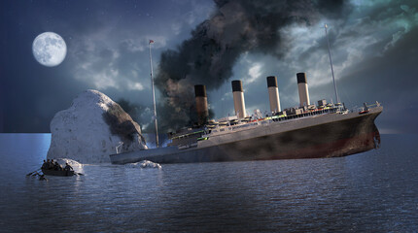

NENE

10ALYTICS

**TITANIC CASE STUDY REPORT**

**Exploratory Data Analysis**

1.Total number of passengers onboard the ship No. of Passengers 418

2. Passengers by class

|  |  |
| --- | --- |
| **Number of passengers by class** | |
| 1st class | 107 |
| 2nd class | 93 |
| 3rd class | 218 |
| Total | 418 |

3. Passengers by sex (male and female)

|  |  |
| --- | --- |
| **Passengers by sex** | |
| Male | 266 |
| Female | 152 |
| Total | 418 |

4. Passengers by Age groups

|  |  |
| --- | --- |
| **Age group** | **Number of passengers** |
| 0-19 | 61 |
| 20-39 | 275 |
| 40-59 | 68 |
| >60 | 14 |
| Total | 418 |

5. Age group with most and least passengers

|  |  |  |
| --- | --- | --- |
| **Age group** | | **Number of passengers** |
| Most | 20-39 youth | 275 |
| Least | >60 Elder | 14 |

6. Passengers with siblings on board

|  |  |
| --- | --- |
| **Passengers** | **Number of siblings** |
| 283 | Had no sibling |
| 110 | 1 |
| 14 | 2 |
| 4 | 3 |
| 4 | 4 |
| 5 | 1 |
| 8 | 2 |

7. Passengers with children on board

|  |  |
| --- | --- |
| **Passengers** | **Number of children** |
| 1 | 0.17 |
| 1 | 0.33 |
| 1 | 0.75 |
| 1 | 0.83 |
| 1 | 0.92 |
| 3 | 1 |
| 2 | 2 |
| 1 | 3 |
| 1 | 5 |
| 3 | 6 |
| 1 | 7 |
| 2 | 8 |
| 2 | 9 |
| 2 | 10 |
| 1 | 11.5 |
| 2 | 12 |
| 3 | 13 |
| 2 | 14 |
| 1 | 14.5 |
| 1 | 15 |
| 2 | 16 |
| 7 | 17 |

8. Fare Prices.

|  |  |  |  |
| --- | --- | --- | --- |
| **Total fare prices** | **Average fare prices** | **Max fare prices** | **Min fare prices** |
| **£14,891.54** | **£35.63** | **£512.33** | **£3.17** |

9. Passengers by location

|  |  |
| --- | --- |
| **Locations** | **Number of passengers** |
| Queenstown | 46 |
| Southampton | 270 |
| Cherbourg | 102 |

vv

10. Passengers by Sex and Class

|  |  |  |  |
| --- | --- | --- | --- |
| **Sex** | **Class** | | |
|  | **3rd** | **2nd** | **1st** |
| Male | 146 | 63 | 57 |
| Female | 72 | 30 | 50 |

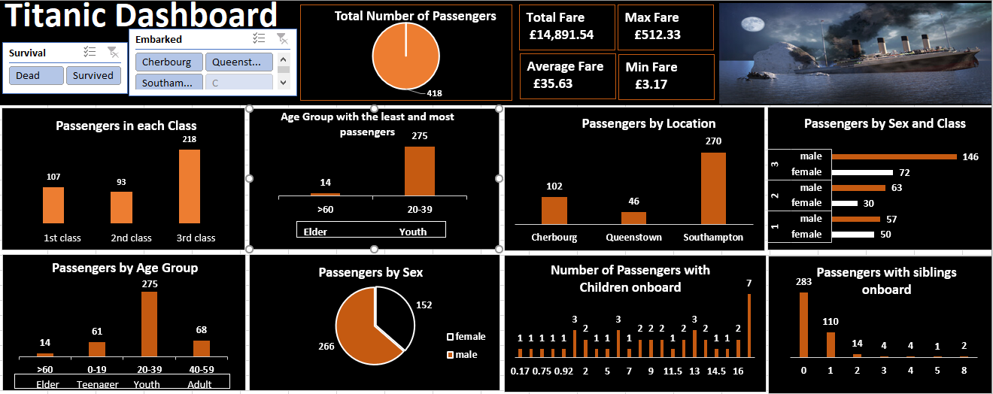

**Tailored Data Analysis**

1. No. of dead and Survived passengers

|  |  |
| --- | --- |
| No. of Passengers | |
| Survived | 152 |
| Dead | 266 |

Survived Passengers 152

Dead Passengers 266

1. Survived Passengers by Sex

|  |  |
| --- | --- |
| Survived | No. of Passegers |
| Female | 152 |
| Male | 0 |
| Total | 152 |

1. Survived Passengers by Class

|  |  |
| --- | --- |
| Class | Survived |
| 1st Class | 50 |
| 2d Class | 30 |
| 3rd Class | 72 |
| Total | 152 |

1. Survived Passengers by Age group

|  |  |
| --- | --- |
| Survived by Age Group | No. of Passengers |
| >60 Elder | 7 |
| 1-19 Teenager | 28 |
| 20-39 Youth | 94 |
| 40-59 Adult | 23 |
| Total | 152 |

1. Survived Passengers by Embarked Location

|  |  |
| --- | --- |
| Survived by Location | No. of Passengers |
| Cherbourg | 40 |
| Queenstown | 24 |
| Southampton | 88 |
| Total | 152 |

1. Survived Male to Female Ratio by Class

|  |  |  |
| --- | --- | --- |
| Class | Male | Female |
| 1st Class | 0 | 50 |
| 2d Class | 0 | 30 |
| 3rd Class | 0 | 72 |
| Total | 0 | 152 |

1. Survived Male to Female Ratio by Age Group

|  |  |  |
| --- | --- | --- |
| Class | Male | Female |
| >60 | 0 | 7 |
| 1-19 | 0 | 28 |
| 20-39 | 0 | 94 |
| 40-59 | 0 | 23 |
| Total | 0 | 152 |

**Survived Passengers Dashboard**

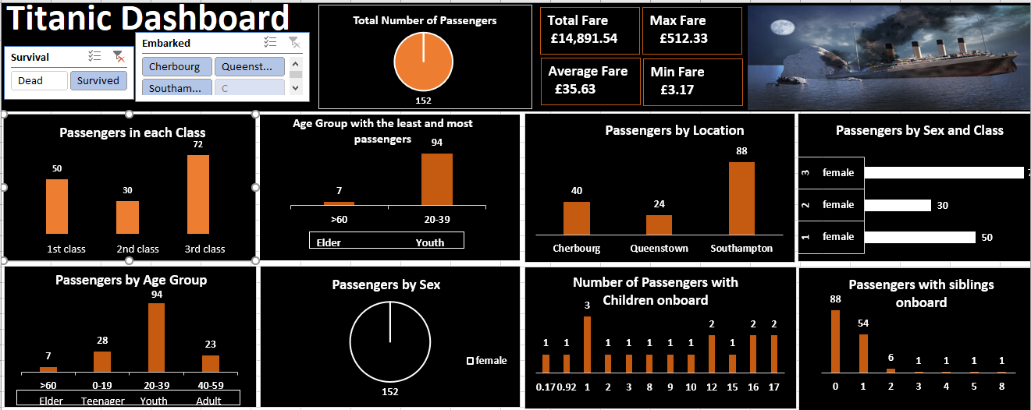

**Dead Passengers Dashboard**

